TISSUES

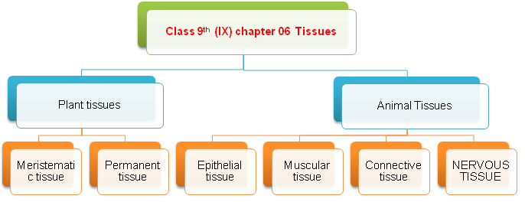

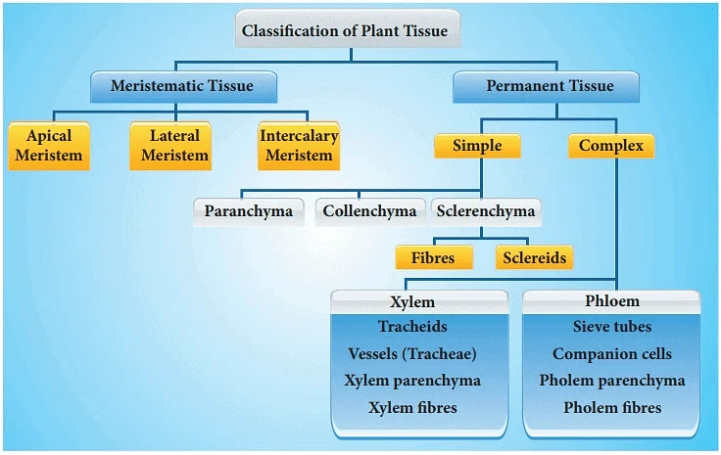

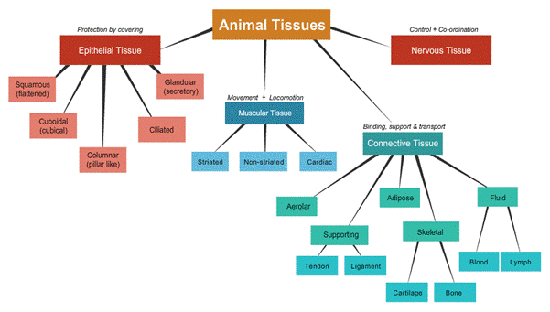

Tissues
Group of cells having a common origin and similar function are termed as tissues.
A. Plant tissues: On the basis of the dividing capacity, plant tissues are of two types:
- Meristematic tissues
- Permanent tissues
1. Meristematic tissues: Consist of actively-dividing cells. Meristematic tissues are of three types:
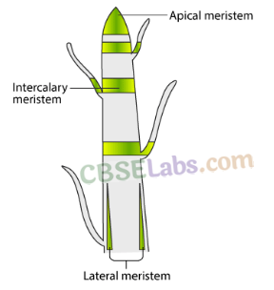
- Apical meristem: Present at the growing tips of stems and roots. Important function: To increase the length of stems and roots.
- Intercalary meristem: Present at the base of leaves or internodes. Important function: For the longitudinal growth of plants.
- Lateral meristem: Present on the lateral sides of the stems and roots. Important function: To increase the thickness of stems and roots.
2. Permanent tissues: Formed from meristematic tissues, the cells in the tissue loose the ability to divider Permanent tissues are divided into two categories:
- Simple permanent tissue: Consist of only one type of cells.
Types of simple permanent tissues:
  - Parenchyma: Composed of unspecialised living cells with relatively thin cell walls, intercellular space, present in soft parts of the plant. Their main function is storage.
  - Collenchyma: Composed of living and elongated cells with cell walls irregularly thickened at the comers. No intercellular space. It provides mechanical support and elasticity to plant. It helps in bending of leaves and stems.
  - Sclerenchyma: Composed of long, narrow, and thick-walled cells. This tissue is made up of dead cells and there are no intercellular spaces. Sclerenchyma cells are dead, present in seeds, nuts, the husk of a coconut, fibres of jute etc.
IDENTIFY PARENCHYMA
- 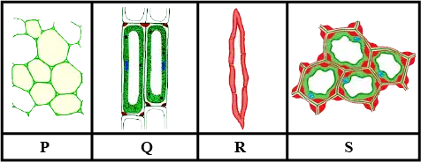

- Complex permanent tissue: Made up of more than one type of cells (Conducting tissues.)
Types of complex permanent tissues:
  - Xylem: Conducts water and minerals from the roots to the different parts of the plant.
Composed of four different types of cells—tracheids, vessels, xylem parenchyma and xylem fibres.
  - Phloem: Conducts food material from the leaves to the different parts of the plant.
Composed of four different types of cells—sieve tubes, companion cells, phloem parenchyma and phloem fibres.
Protective tissue: It is made of a single layer of cells. E.g., epidermis. The epidermis of the leaf bears stomata.

B. Animal tissues: Animal tissues are classified into four types based on the functions they perform:
- Epithelial
- Connective
- Muscular
- Nervous

- Epithelial tissues: Form the covering of the external surfaces, internal cavities and organs of the animal body. Various types of epithelial tissues are:
  - Simple squamous epithelium: Single layer of flat cells.
Location in the human body: Lining of the mouth, oesophagus, lung, alveoli, etc.
  - Cuboidal epithelium: Consists of cube like cells.
Location in the human body: Lining of the kidney tubules and ducts of the salivary glands. It’s function is secretion and absorption.
  - Columnar epithelium: Consists of elongated or column-like cells.
Location in the human body: Inner lining of the intestine and gut. Its function is of secretion and absorption.
- Connective tissues: Specialised to connect various body organs. Various types of connective tissues:, are:
  - Areolar tissue: Found in the skin and muscles, around the blood vessels, nerves, etc.
  - Adipose tissue: Acts as the storage site of fats; found between the internal organs and below the skin; acts as an insulator for the body.
  - Dense regular connective tissue: Main components are tendons and ligaments; tendons connect muscles to bones, while ligaments connect two bones together.
  - Skeletal tissue: Main components of skeletal tissues are cartilage and bone.
  - Fluid tissue: Blood is the vascular tissue present in animals.
- Muscular tissues: Main function of muscular tissues is to provide movement to the body. Muscular tissues are of three types:
  - Striated muscles or skeletal muscles or voluntary muscles: Cells are cylindrical, unbranched and multinucleate.
  - Smooth muscles or involuntary muscles: Cells are long, spindle-shaped and possess a single nucleus.
  - Cardiac muscles or involuntary muscles: Cells are cylindrical, branched and uninucleate.
- Nervous tissues: Present in the brain, spinal cord and nerves.
  - Neuron: Cells of the nervous tissue.
  - A neuron: consists of a cell body, an axon and a dendrite.

